Shave and Punch biopsies
Shave biopsies “Shave Skin”
- Record measurements (L x W)
- Describe and measure any lesions and distance to closest margin
- Ink key
- If greater than or equal to 0.4 cm, bisect or serially section and submit in its entirety

Example dictation:
Received is a formalin container labeled “patients name/MRN” and designated “_____”, containing a tan (irregular, hair bearing, roughened, etc) skin shave, __ x __ cm, with a ______ on the cutaneous surface, __ x __ cm that is __ cm to the closest resection margin which is inked _____. The specimen is bisected and entirely submitted in (A1).
Punch biopsies “Punch Skin”
- Record measurements (diameter x greatest depth)
- Describe and measure any lesions and distance to closest margin
- If greater than or equal to 0.4 cm, bisect or (rarely) trisect and submit in its entirety
- ***IF requisition states alopecia or hair loss gross per alopecia protocol (below) or call derm attending if not sure***
- If punch is NOT bisected, put “not bisected” in the comments in the histo tab for histology or “bisected” in the comments if it was bisected.

Example dictation:

Received is a formalin container labeled “patients name/MRN” and designated “____”, containing a tan skin punch __ cm in diameter and excised to a maximum depth of ___ cm. There is a ____ on the cutaneous surface, __ x __ cm that is __ cm to the closest resection margin that is inked ____. The specimen is submitted in toto in (A1).

Alopecia protocol
- ‘Alo’ on the cassette (if additional blocks, add ALO in ‘other block number’)
- Alopecia in the pre-op diagnosis or clinical history
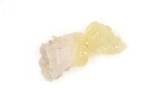
- Must be grossed and inked according to alopecia protocol- ask one of the gross techs if there is a question
- Measure and describe like a punch
- Bisect the punch and on one half ink the cut surface black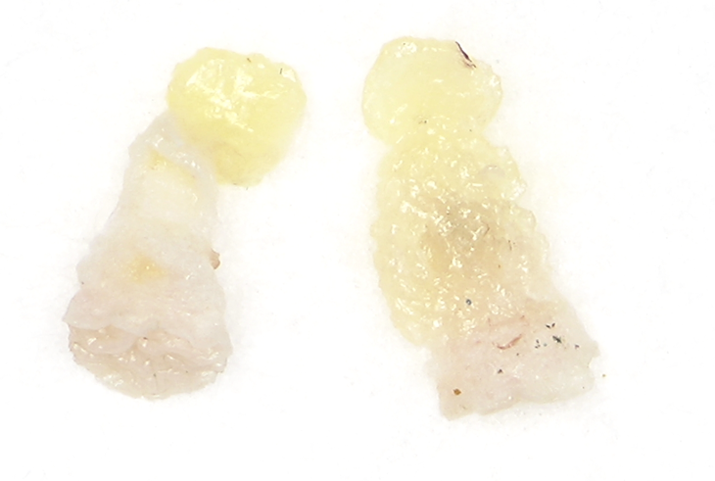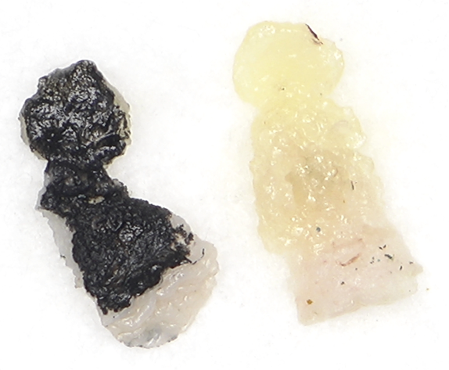
- For the other half, cut it in half perpendicular to the first cut (perpendicular to the long axis) and ink those cut surfaces on each piece
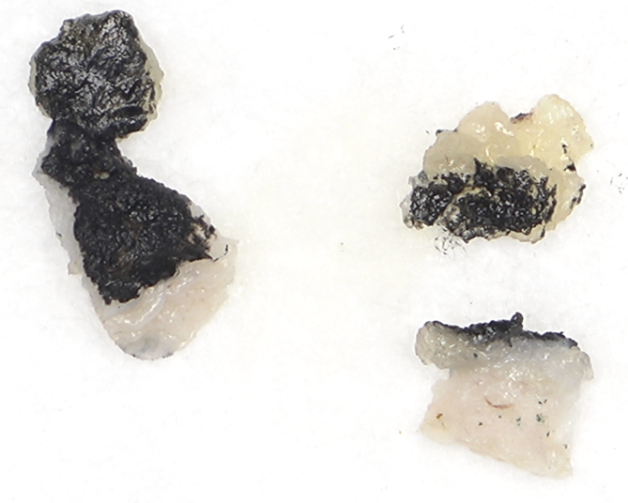
- Put all three pieces black ink down on a lens paper, fold, and put in a cassette
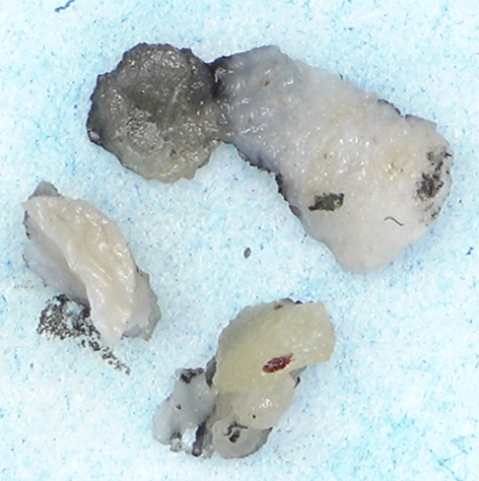
- Add “ink down” in the comments field for the block
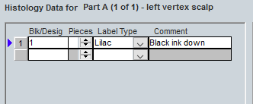
Sample dictation:
“Alo skin”
Received is a formalin container labeled “[patients name/MRN]” and designated “[____]”, containing a [tan] skin punch [__] cm in diameter and excised to a maximum depth of [___] cm. There are no lesions or discolorations noted. The specimen is processed according to the alopecia protocol and submitted entirely in ([A1]).

